**Project Timeline:**

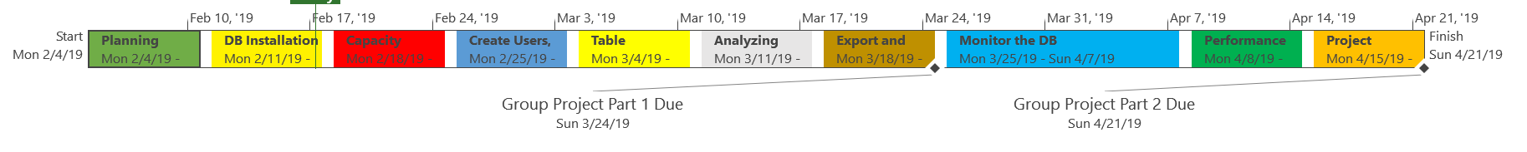

The project time line identifies the allocated time for completion of each task.

**Project Schedule:**

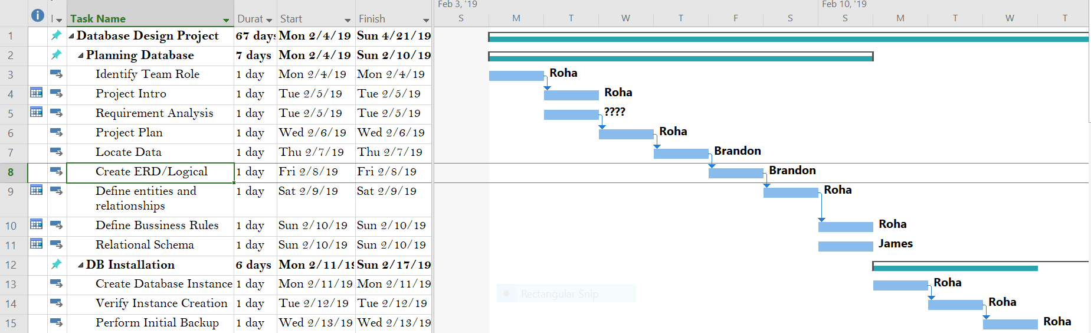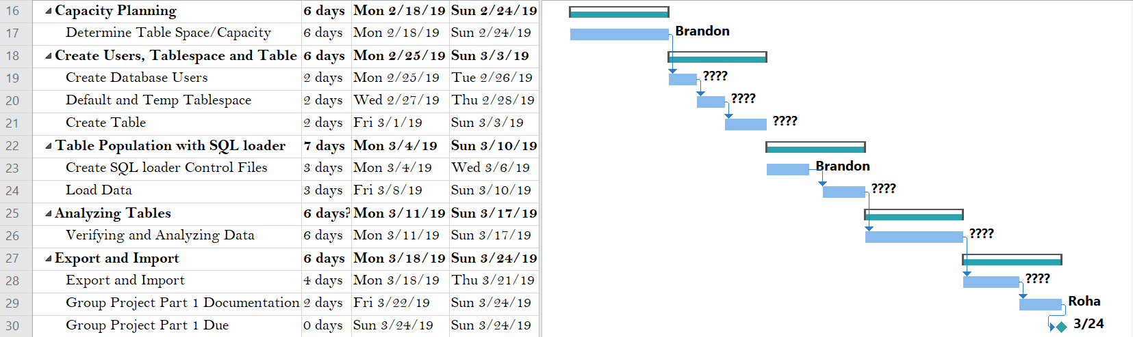

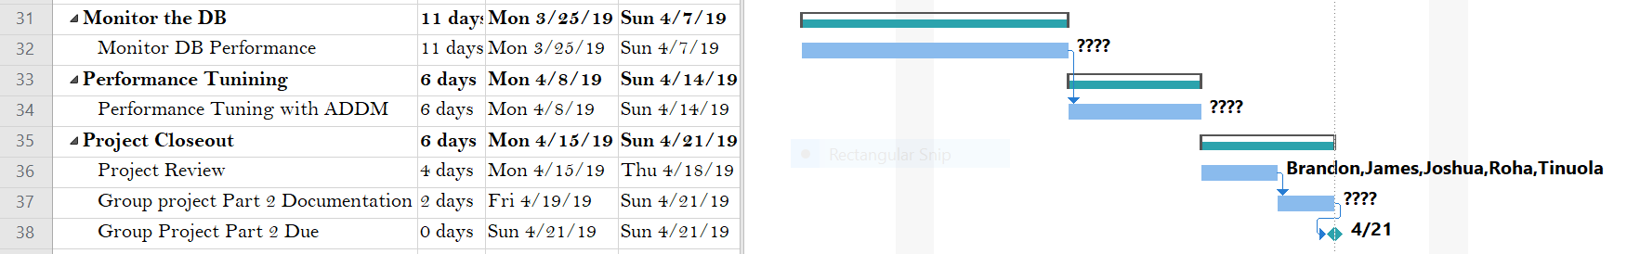

The above project schedule identifies the schedule of tasks and who will be responsible for completion. This Gantt chart shows the timeline for each task, milestone, the names of the project resources assigned to each task and the proposed start and end date for the entire project.